"Found It!": Improving Usability of Conversational AI
through Context-Aware refinding Interaction
Team 2 (HyeokJae Cho, Hyunji Jeong, Boyoung Kwon, Suyoung Kwon, Jieun Woo)

1. Introduction
1.1. Designed Situation
Conversational AI services such as ChatGPT, Claude, and Gemini have evolved beyond simple question-answering tools into task-oriented platforms that support ongoing, context-rich workflows in research, coding, and writing. As users engage with these services over extended periods, their conversation histories grow into valuable personal knowledge repositories that they frequently need to revisit. However, our prior analysis of existing services revealed three persistent limitations that hinder effective refinding: (1) limited search scope and logic, where systems rely on incomplete metadata or shallow matching rather than full-content retrieval; (2) linear navigation structures that lack efficient reorientation support, often forcing users to scroll through long sessions to locate a specific passage; and (3) fragmented context management, where saved or extracted information loses its connection to the original conversational flow. These limitations collectively create a significant usability gap for users who depend on past interactions as a foundation for continued work.

1.2. Scope of This Project
This project focuses specifically on the refinding experience within conversational AI interfaces. We do not address the broader design of conversational AI systems (e.g., response quality, model capabilities) or general-purpose information retrieval systems. Instead, our scope is limited to the interface and interaction layer that supports users in locating, recognizing, and reusing content from their past conversations. The target platform context is web-based conversational AI services with persistent chat history (e.g., ChatGPT, Claude), and our design work centers on enhancing the conversation history management and retrieval features within such platforms.

1.3. Statement of Purpose
As conversational AI services become increasingly embedded in knowledge-intensive workflows, users accumulate rich interaction histories that serve as ongoing reference points across tasks. Yet current services provide only limited support for retrieving and reusing these past interactions. This project aims to address these gaps by investigating how users actually experience refinding in practice and by identifying the design requirements that emerge from those experiences. Specifically, we seek to characterize users’ behavioral patterns and pain points around refinding, analyze the contextual factors that shape when and how it occurs, and derive core system functions that could meaningfully improve the usability of conversational AI for users who depend on prior interactions as a foundation for continued work.
i. Intended Users
Our intended users are graduate student researchers who regularly use conversational AI services (e.g., ChatGPT, Claude) for knowledge-intensive tasks such as literature review, data analysis, and writing, and who have accumulated substantial conversation histories over weeks or months that they need to revisit.
ii. Key Tasks
The key tasks are centered on refinding and reusing specific information within past conversational AI interactions. The primary task is refinding: (1) locating a previously generated answer when the user remembers only partial cues such as approximate timing, topic keywords, or task type; and (2) navigating within a retrieved conversation to reach the exact passage of interest. The secondary task is reusing: (3) extracting or referencing the re-found content in a new context, such as continuing a previous line of reasoning, adapting a prior solution to a related problem, or consolidating insights from multiple past conversations.

2. Requirement Analysis
A. Defined User Requirement Results
Based on the observations and interviews, we classified users into two types, Search type and Question type, according to their usage patterns of conversational AI services. We then identified the pain points of each user type and derived six user needs based on the core causes of these pain points. For each need, we constructed a corresponding use case, resulting in six use cases in total (See Appendix A.1).
We analyzed what requirements were necessary for each use case to work properly, and as a result, derived approximately 36 use case requirements, with six requirements for each use case, from user interviews and observations. We also found that some requirements were similar across different use cases. By consolidating these overlapping requirements, we refined them into 19 requirements. Among these, two requirements, R18 and R19, were judged difficult to translate into user interface functions, so they were excluded from the later function derivation process (See Appendix A.2).

B. System Requirements
Based on the user requirements identified in Section 2.A, we translated each requirement into a corresponding system function. This process yielded 17 candidate functions, which are summarized in Figure 1. Considering the available development time and project scope, we prioritized implementing a focused set of core functions in the prototype.
To prioritize which functions to include, we employed a weighted Pugh matrix. First, we defined six evaluation criteria based on the core user needs identified from the requirements analysis, such as understanding conversation structure, controlling the search scope, finding past answers without exact keywords, judging relevance before opening results, and quickly navigating back to the original conversation. Each criterion was assigned a weight according to its relative importance. We then evaluated each candidate function against these criteria using a comparative scoring scheme, where positive, neutral, and negative contributions were marked and converted into weighted scores. The final weighted scores allowed us to identify the functions that best addressed high-priority user needs while remaining feasible within the prototype scope. We selected the highest-scoring functions as the core functions to carry forward into the design phase.
Based on this, six functions were selected as core system requirements: Set reference scope, Open original conversation, Structure sessions, Search semantically, Preview candidate content, and Rank by relevance. These functions were selected because they received relatively high weighted scores and directly addressed the most important evaluation criteria, especially finding past answers without exact keywords, judging result relevance before opening a conversation, and navigating quickly back to the original conversation context.
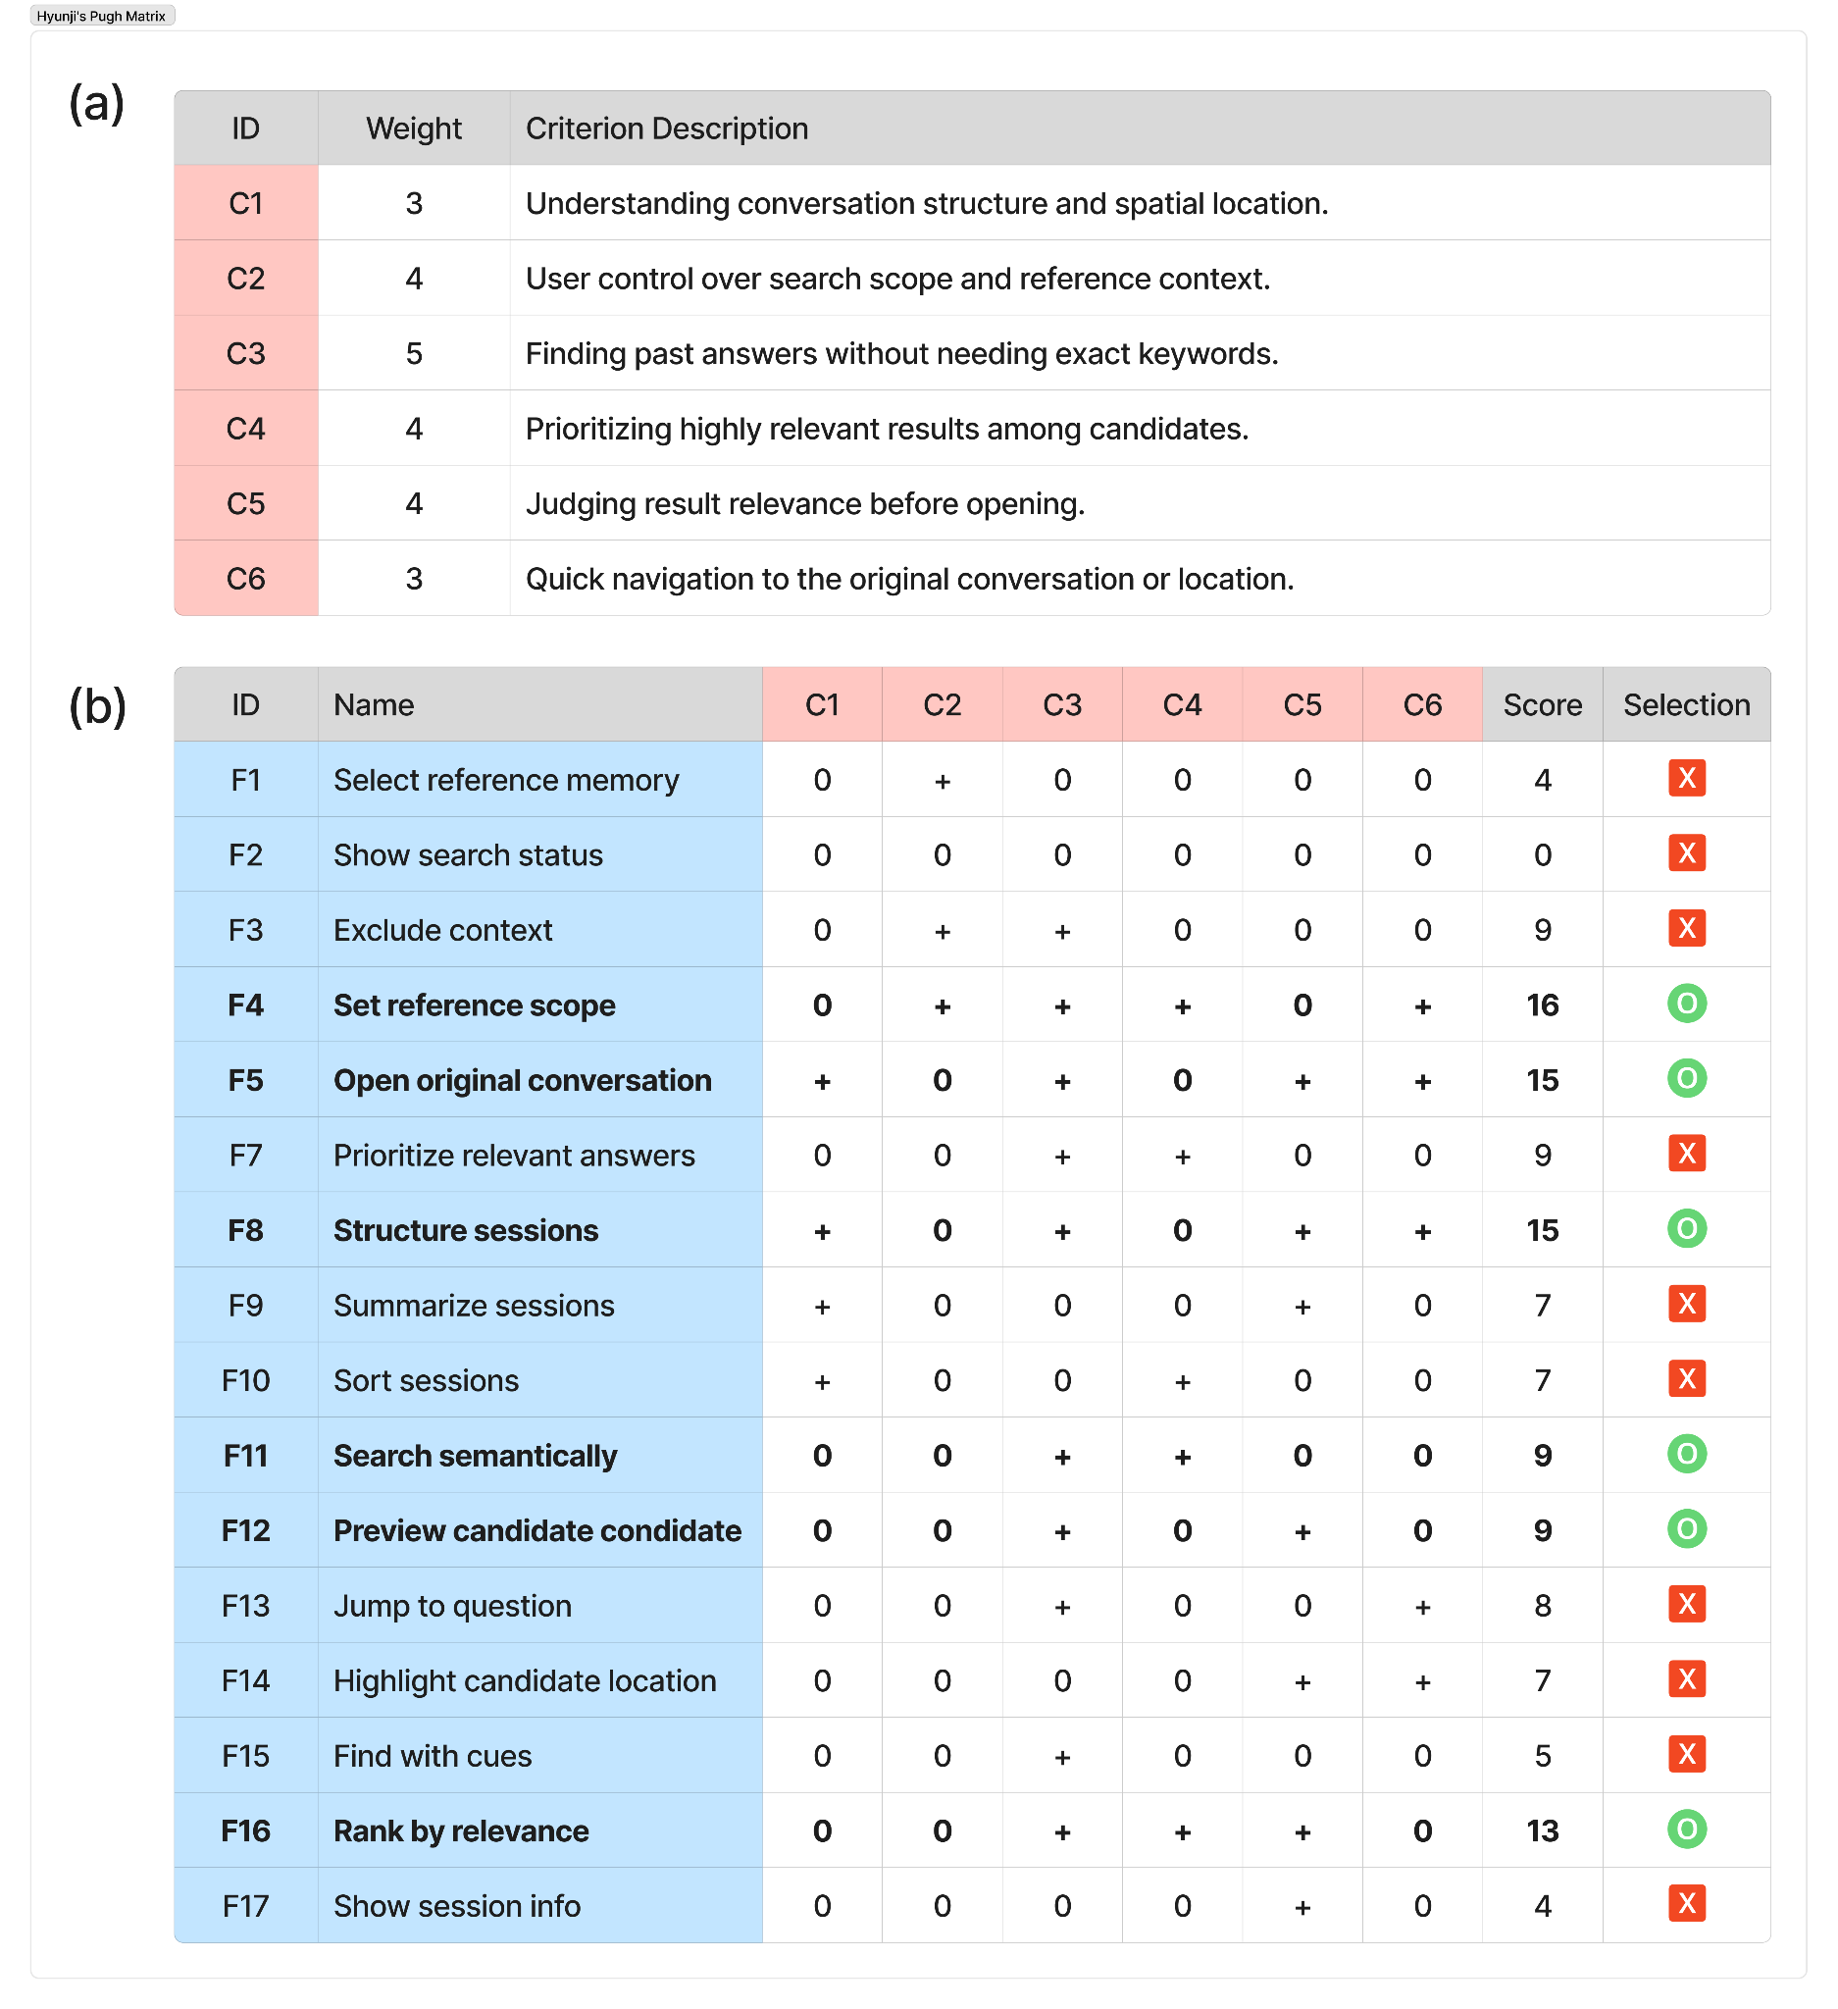
Figure 1. Weighted Pugh matrix for prioritizing core functions. (a) Evaluation criteria and their assigned weights. (b) Weighted Pugh matrix used to compare candidate functions and select the core functions for prototyping.

Set reference scope was selected because it received the highest score in the matrix. This function supports users in controlling the search scope and reference context, which is essential when users do not want the system to search across all past conversations indiscriminately. By allowing users to define whether the search should focus on the current session, selected conversations, or broader history, this function reduces irrelevant results and gives users greater control over the retrieval process.
Open original conversation was also selected because it strongly supports re-entry into the original context. Since users often need not only the answer itself but also the surrounding conversational flow, this function helps preserve the link between retrieved content and its source conversation. It addresses the need for quick navigation to the original location and prevents found information from becoming detached from its original context.
Structure sessions was selected because it helps users understand the organization and spatial location of past conversations. Instead of presenting conversation history as a purely chronological list, this function supports structured recognition of sessions, making it easier for users to reorient themselves when searching through accumulated chat histories. This is especially useful when users remember the task or topic but not the exact wording of the conversation.
Search semantically was selected because it directly addresses one of the most critical user needs: finding past answers without needing exact keywords. Since users often remember vague cues, approximate topics, or the purpose of a prior conversation rather than exact phrases, semantic search can bridge the gap between the user’s memory and the stored conversation content.
Preview candidate content was selected because users need to judge whether a result is relevant before opening it. By showing a preview of the matched answer or surrounding context, the system helps users verify relevance quickly and reduces unnecessary navigation. This function is especially important for avoiding repeated trial-and-error when multiple search results appear similar.
Rank by relevance was selected because it improves the efficiency of result exploration. When many candidate conversations or answer bubbles are returned, users need the most likely matches to appear first. This function supports prioritizing highly relevant answers among candidates and reduces the cognitive effort required to scan through search results.
Overall, the selected functions cover the main stages of the refinding process: defining the search scope, retrieving results through semantic cues, organizing and ranking candidates, previewing their relevance, and returning to the original conversation context. Therefore, they were carried forward as the core functional basis for the design alternatives.

C. Design Alternatives
Based on the core functions selected in Section 2.B, we constructed a morphological chart to explore multiple design options for each function. Each row of the chart represents a selected function, and each column presents a distinct low-fidelity design option illustrated with sketches. By selecting different combinations of options across rows, we derived three design alternatives, each representing a coherent design direction with distinct trade-offs.
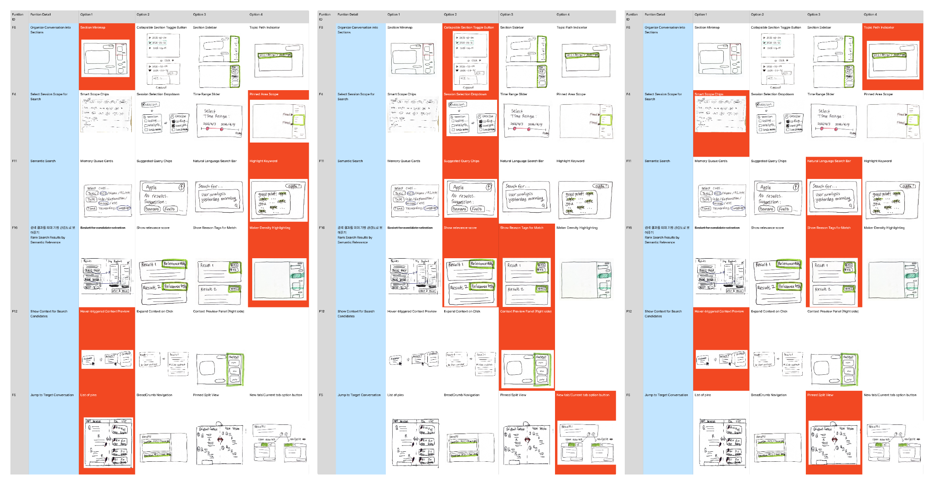
Figure 2. Three selected alternatives from the morphology chart. The full morphology chart is provided in Appendix B.

In the following, we present three design alternatives. Full screenshots of each alternative can be found in Appendix C.
i. Alternative 1
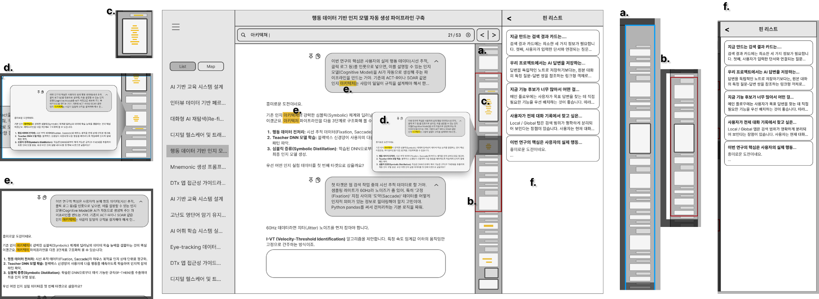
Figure 3. Mid-fidelity prototype overview of Alternative 1.

Alternative 1 focuses on helping users refind past conversations through spatial and structural cues. This design uses a section map (a) to show the overall structure of a conversation, allowing users to understand where each part of the conversation is located. For search scope control, it uses a pinned area scope (b), enabling users to limit the search to a specific pinned or marked region. Semantic search is supported through highlighted keywords (e), and candidate relevance is visualized through marker density highlighting (c), which shows where relevant content is concentrated within the conversation. Users can preview candidate content through a hover-triggered preview (d), and they can jump back to target conversations using a list of pins (f).
This alternative is useful for users who remember the approximate location or structure of a past conversation rather than the exact wording. It supports reorientation by making the conversation visually navigable. However, it may become less effective when the conversation history is very large or when users do not have clear spatial memory of the target content.

ii. Alternative 2
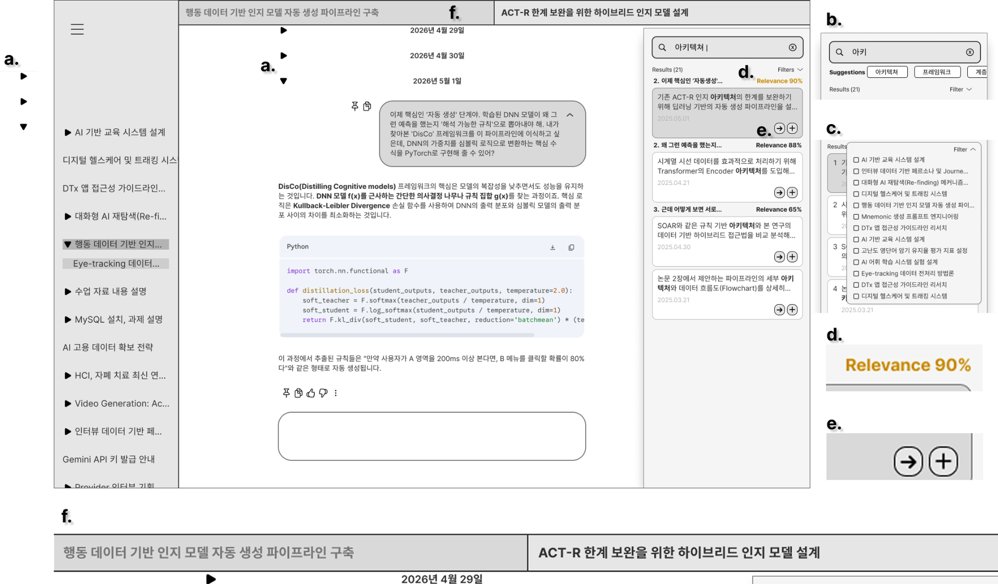
Figure 4. Mid-fidelity prototype overview of Alternative 2.

Alternative 2 emphasizes user control and result verification. It uses a collapsible section toggle button to organize conversation sections while keeping the interface compact. For search scope control, it provides a session selection dropdown, allowing users to explicitly select which sessions should be included in the search. Semantic search is supported through suggested query chips, which help users formulate search queries even when they only remember partial cues. To help users evaluate search results, this design provides both a relevance score and a reason tag for match, making it easier to understand why each result was retrieved. Candidate content is shown in a right-side context preview panel, and users can open the original conversation through a new tab/current tab option.
This alternative is suitable for users who want precise control over the search process and need strong evidence before deciding which result to open. Its strength lies in reducing uncertainty during result selection. However, because it includes many explicit controls and explanatory elements, it may feel more complex than the other alternatives.
iii. Alternative 3
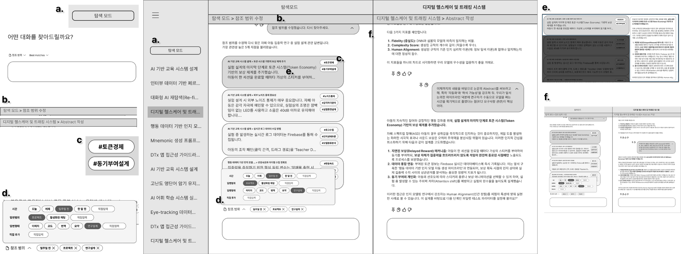
Figure 5. Mid-fidelity prototype overview of Alternative 3.

Alternative 3 aims to provide a more minimal-effort and context-preserving refinding flow.
It uses a topic path indicator (b) to show where the user is within the conversation structure, helping users understand the current position of the retrieved content. Search scope is controlled through smart scope chips (d), allowing users to quickly adjust the reference scope without opening complex menus. Semantic search is supported through a natural language search bar (a), which lets users enter vague or conversational cues rather than exact keywords. Result relevance is explained through reason tags for match (c), helping users understand why each candidate was retrieved. Candidate content can be checked through a hover-triggered content preview (e), and users can return to the original context using a pinned split view (f), where the retrieved result and its original conversation location can be viewed together.
This alternative reduces the amount of setup required before searching while still preserving the connection between search results and their original context. It is useful when users remember only vague cues and want to quickly verify candidates without fully leaving their current workflow. However, because it relies on compact elements such as smart scope chips and reason tags, some users may need time to understand how the scope control and relevance explanation work.

3. Evaluation of Design Alternatives
A. Client Sample
We recruited eight KAIST student researchers as evaluation participants. Seven of the eight participants were carried over directly from the user analysis phase, and one participant from the original group was unavailable due to scheduling conflicts and was replaced by a researcher with a comparable profile.

B. Evaluation Criteria
Evaluation criteria were established along two dimensions to reflect the project’s core goals. The primary dimension, system effectiveness, focused on whether each alternative supports key refinding behaviors: locating a target answer again (Refinding effectiveness), recognizing it without exact memory (Recognition support), searching with diverse cues (Cue flexibility), and immediately reusing retrieved content (Reuse readiness). The secondary dimension, cost, captured trade-offs across alternatives in terms of cognitive burden (Cognitive cost), interaction effort (Interaction cost), user frustration (Frustration cost), and system responsiveness (Latency cost). Participants evaluated each alternative against these criteria through a post-experience questionnaire and a follow-up interview, with this process repeated for all three alternatives. The full list of survey items is provided in the Appendix D.

C. Results
i. Quantitative Results
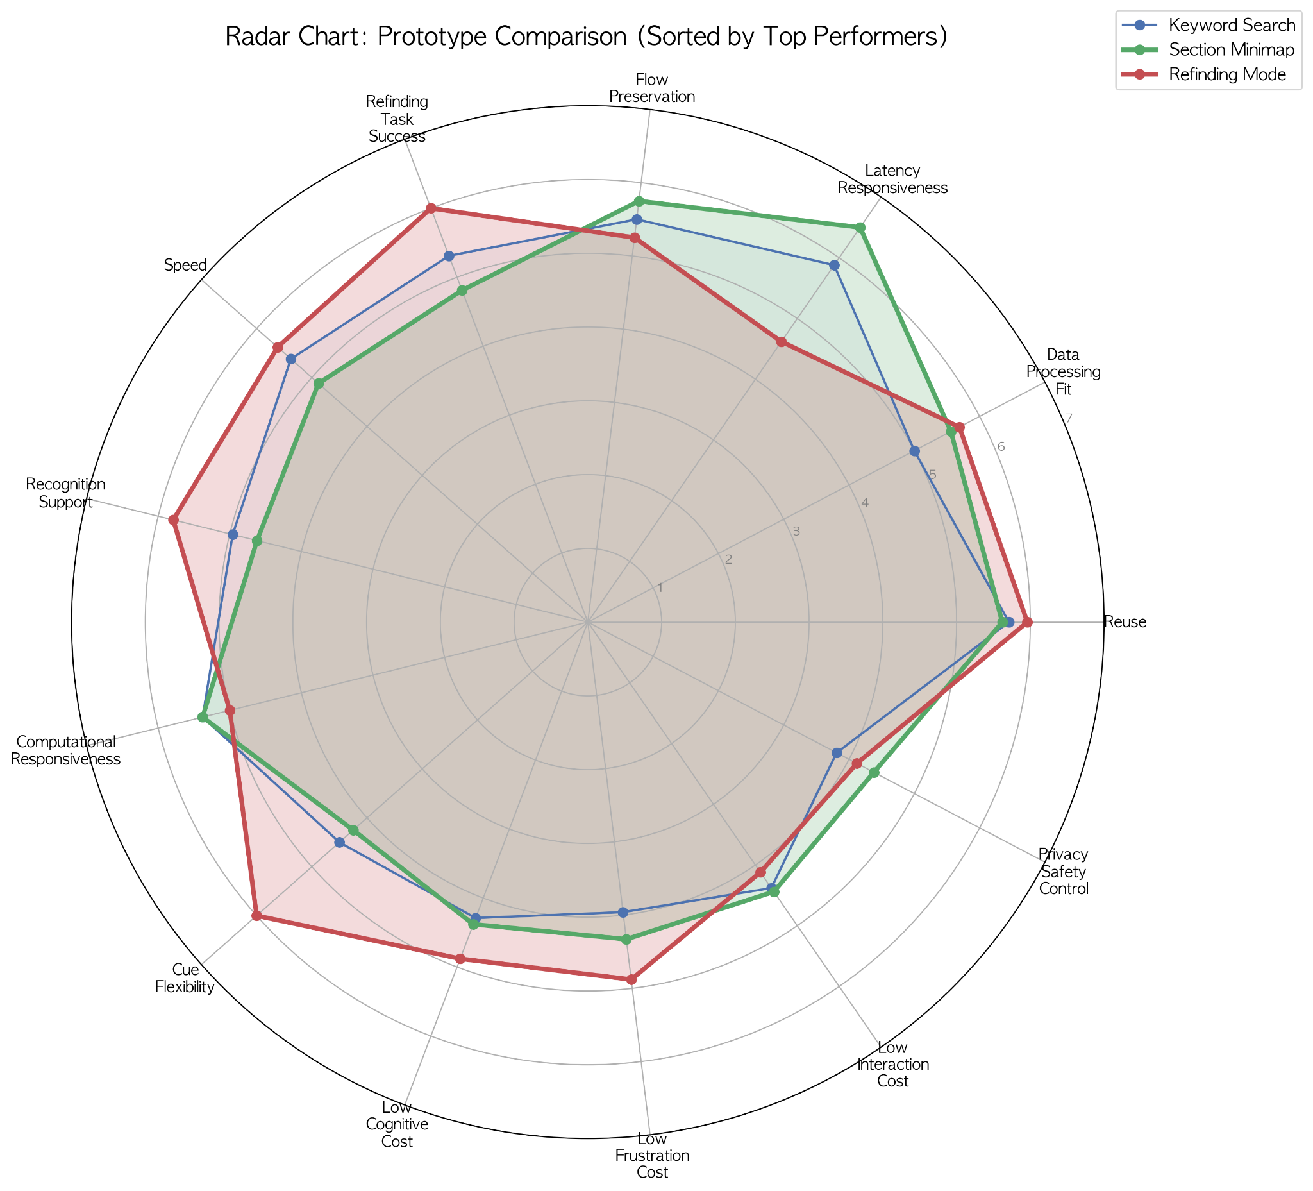
Figure 6. Quantitative comparison of alternative performance across evaluation criteria.

Quantitative survey responses were averaged across participants for each construct and visualized as a radar chart to compare the three alternatives across multiple dimensions (Figure 6). The results revealed distinct strength profiles for each prototype.
Alternative 3 (denoted as Refinding Mode in Figure 6) achieved the highest scores on constructs directly tied to the core refinding objective, including refinding task success, recognition support, reuse, and cue flexibility. This suggests that Alt 3 is most effective at fulfilling the primary goal of helping users locate and reuse past conversation content, even in the absence of exact keywords.
Alternative 1 (denoted as Section Minimap in Figure 6) led on flow preservation and latency responsiveness, reflecting its lightweight integration into the existing interface. Participants perceived it as the least disruptive option, with low interaction and frustration costs relative to the other alternatives.
Alternative 2 (denoted as Keyword Search in Figure 6) did not lead on any single construct but showed moderate scores across dimensions, suggesting a generalist profile without a clear differentiating strength.
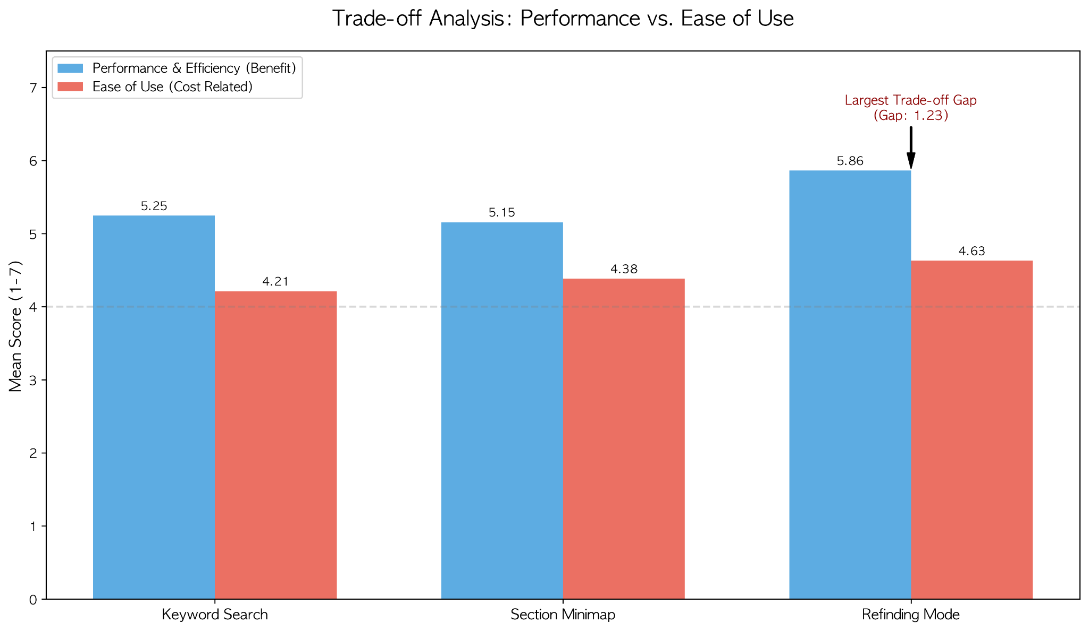
Figure 7. Trade-off analysis supporting the selection of refinding mode.

Figure 7 compares the mean participant ratings of the top prototype concepts in terms of benefit-related criteria and ease-of-use-related criteria. Refinding Mode showed the highest benefit score, while maintaining an acceptable ease-of-use score. Although it had the largest trade-off gap, its strong expected benefit led to its selection as the final prototype direction.

ii. Qualitative Findings
Open-ended comments were analyzed using an LLM-assisted sentiment coding scheme, in which each response was assigned a score from -3 (strongly negative) to +3 (strongly positive) and subsequently verified by a human rater (Tai et al., 2024; Torii et al., 2024). Neutral or absent responses were assigned a score of 0. The full expert interview protocol and response summary are provided in Appendix E.
Sentiment scores and open-ended comments were analyzed across the three prototypes to identify recurring themes and points of divergence.
Alternative 1 received broadly positive responses, with the pinpoint navigation feature emerging as a standout element across multiple participants. While some questioned its incremental value over Cmd+F for memory-reliant users, the direct navigation affordance was consistently identified as a concrete usability improvement worth retaining.
Alternative 2 elicited the most polarized reactions. The card-based result view was viewed favorably, but the nested tab structure drew strong criticism for interface complexity, and the branch feature was perceived as redundant by participants who did not already use it in their workflow.
Alternative 3 produced the most substantive qualitative engagement. Participants consistently recognized the core value of the feature, particularly the ability to manually define the reference scope as a meaningful differentiator that addresses token inefficiency in current LLM interfaces. Concerns raised around LLM latency and the checklist-based scope UI were framed as implementation-level issues rather than objections to the concept itself. Notably, the pinpoint-style direct navigation from Alt 1 was also cited in this context as a complementary affordance, suggesting that integrating precise result navigation into the Refinding Mode interaction flow could address the remaining usability gap.
Together, these findings motivated a combined design direction in which the semantic retrieval and scope control of Alternative 3 are paired with the direct navigation mechanism of Alternative 1.

4. Description of the Prototype
A. Features
The final prototype is based on Alternative 3: Minimal-effort Contextual Search and adopts the section minimap from Alternative 1 so that users can understand the original conversational context at a glance. This prototype aims to help users refind past conversational AI responses without complex configuration, while preserving the connection between the retrieved information and the original conversation flow. The prototype consists of five main features.
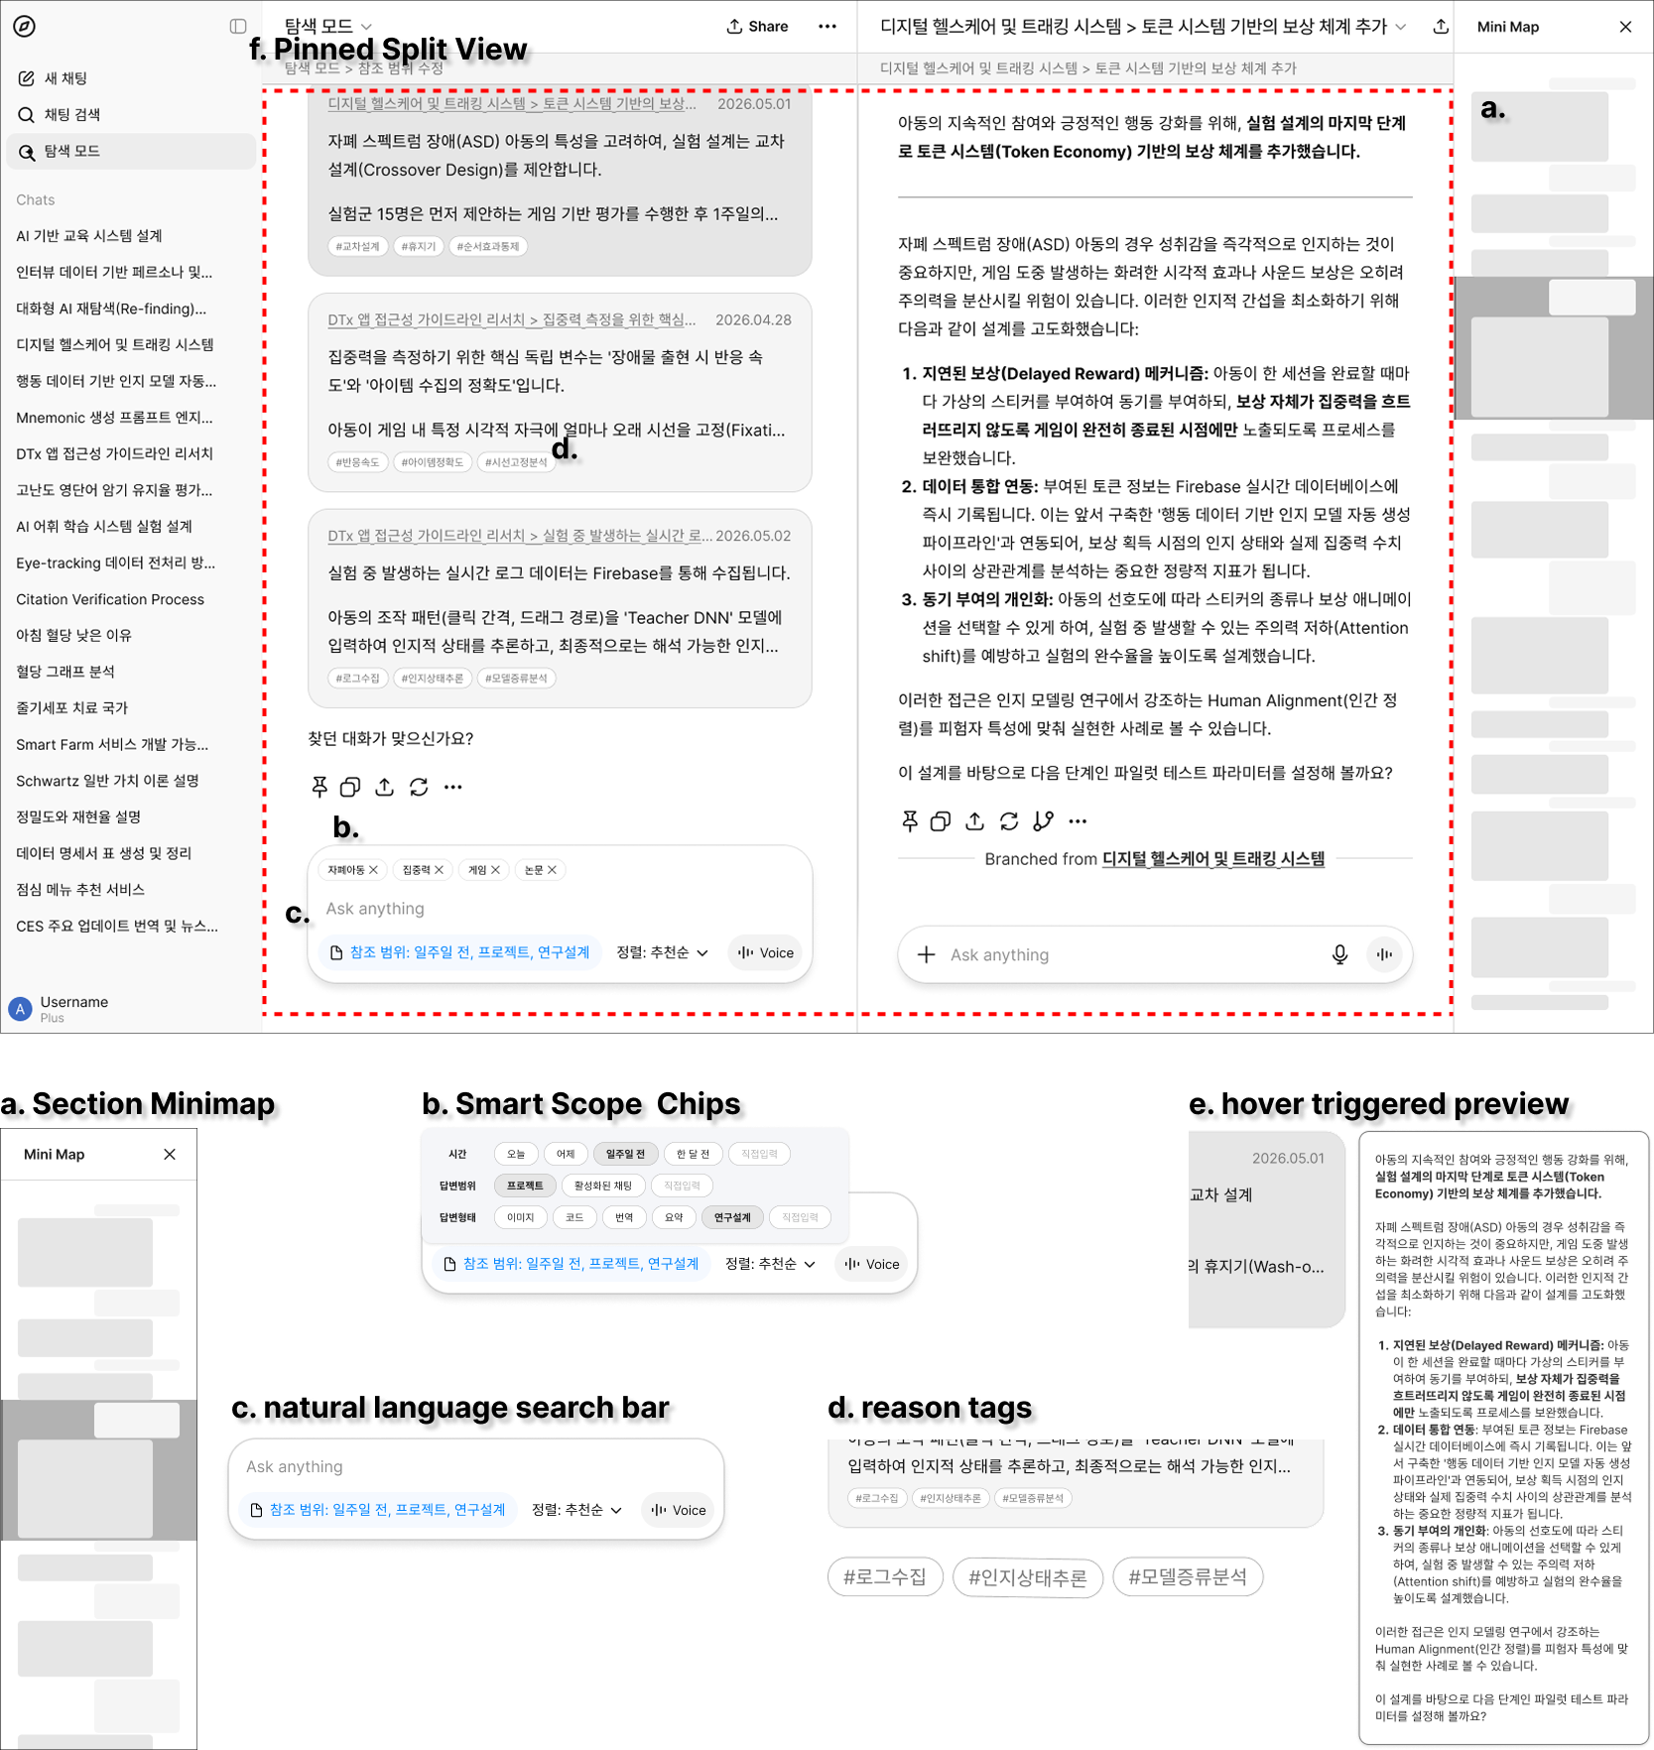
Figure 8. Prototype overview. Full screenshots are available in Appendix G.

First, the section minimap (a) provides a compact visualization of the structure of a long conversation. Without manually scrolling through the entire session, users can roughly identify where the retrieved answer is located within the conversation.
Second, smart scope chips (b) allow users to quickly adjust the search scope. Based on the user’s query, the system automatically suggests relevant scope chips, such as the current conversation, selected sessions, related topics, or the entire conversation history. Users can then choose or modify the reference scope without going through complex filter menus.
Third, the natural language search bar (c) allows users to enter vague or incomplete cues in natural language. Instead of requiring exact keywords, it supports semantic search based on the approximate topic or contextual cues that users remember.
Fourth, the search results are provided with reason tags for matching (d). These tags explain why each result was retrieved and help users judge the relevance of each candidate before opening it.
Fifth, the prototype provides hover-triggered content preview (e) and pinned split view (f). Users can hover over a search result card to quickly preview the candidate answer. When they click the card, a split view opens, and a new tab displays the exact location of the original conversation containing that answer. This allows users to compare the search result with its original conversational context. Alternatively, users can right-click the card to choose whether to open the result in a new tab or navigate to it directly.

B. Interactions
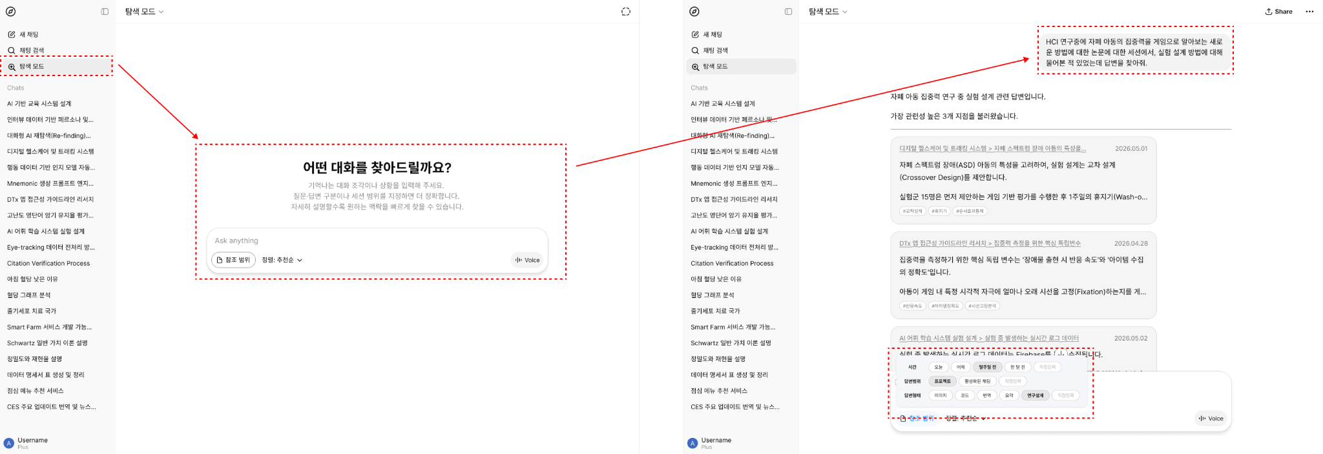
Figure 9. The Refinding Mode interface. The user enters a vague or natural language query into the search bar (left), and the system returns a set of candidate answer cards retrieved from past conversations, with adjustable reference scope (right).
The main interaction flow begins when the user enters a vague cue or natural language query into the search bar. Before or during the search, the user can adjust the reference scope using smart scope chips. For example, the user can search only within the current session, include selected conversations, or search across a broader conversation history.
Once the query is entered, the system presents candidate results ranked by relevance. Each result is shown with a brief preview and reason tags. While scanning the result list, the user can hover over a specific candidate to preview the answer content without opening the full conversation.
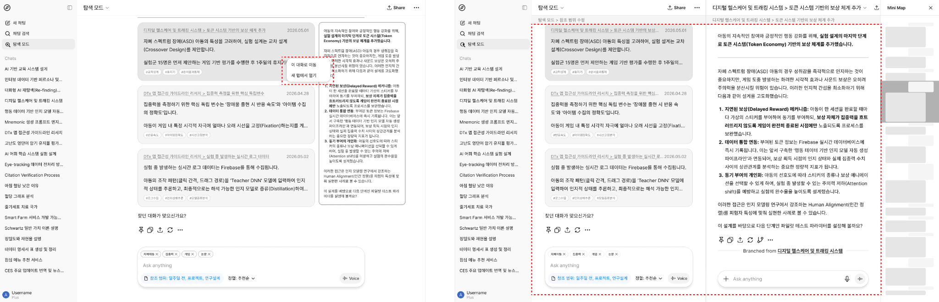
Figure 10. The pinned split view interaction. Upon selecting an answer card, the conversation opens in a new tab jumping directly to the relevant location, while the section minimap (top right) provides spatial context within the surrounding conversation structure.

When the user finds a promising answer card, they can click it. This creates a pinned split view, where the selected answer card is fixed on one side and the original conversation opens in a new tab on the other side. This new tab does not open at the beginning of the conversation; instead, it jumps directly to the location of the selected answer. At this point, the section minimap shows where the answer is located within the long conversation structure and helps the user explore the surrounding context.
Through this flow, the user can go beyond simply checking the search result and also review the question that generated the answer, the surrounding logical flow, and the original task context. Overall, the interaction proceeds in the following order:
entering a partial cue → adjusting the search scope → reviewing candidate results → judging relevance through hover preview → clicking the answer card → checking the original conversation location in split view.

C. Strengths and Limitations
The main strength of this prototype is that it helps users refind past answers even when they do not remember exact keywords. By combining natural language search with semantic search, the prototype allows users to use vague cues, approximate topics, or contextual memories as search inputs, which better reflects how users actually remember past conversations.
Another strength is that it reduces unnecessary navigation. Hover-triggered content preview, reason tags, and relevance-based result ranking help users judge the relevance of each result before opening the full conversation. This reduces trial-and-error behavior, especially when multiple search results appear similar.
In addition, this prototype preserves the connection between retrieved information and its original conversational context. When the user clicks an answer card, a split view opens, and the original conversation jumps directly to the location of that answer. Since the section minimap is also provided, users can understand where the retrieved answer is located within the overall conversation flow and check the surrounding context if needed.
However, the prototype also has several limitations. First, the section minimap may become less effective when conversations are extremely long or poorly structured. In such cases, the minimap may become visually dense or difficult to interpret. Second, smart scope chips and reason tags are compact UI elements, so some users may need time to understand their meanings and how they work. Third, this prototype focuses on the interaction layer rather than the backend retrieval model.
Therefore, the actual accuracy of semantic search and the quality of relevance ranking are outside the scope of this prototype and require further technical implementation and evaluation.
Finally, while this prototype supports refinding and re-entry into the original context, it does not fully solve broader conversation management issues, such as long-term archive organization, automatic summarization across multiple sessions, or collaborative reuse of past AI interactions.

D. Expert Interview
To assess the technical feasibility of the proposed system, we conducted a separate expert interview with an LLM engineer at LG AI Research. The interview covered six dimensions: Technical Feasibility, Data Architecture, Retrieval Pipeline, Latency & Cost, Privacy & Safety, and Open-ended Expert Judgment. The full interview protocol is provided in the Appendix F.
The expert evaluated the proposed system favorably overall. She confirmed that implementing our prototype within existing conversational AI infrastructure is technically feasible (5/5), but stressed that semantic search alone is insufficient, and that an LLM-based query reformulation and reasoning stage is necessary for reliable retrieval. She also noted that a dedicated indexing layer and metadata schema would be essential, and that pre-generating summaries or tags at conversation time would further improve retrieval performance.
On latency and cost, the expert acknowledged that the system would impose substantially higher computational overhead than conventional keyword search, estimating a maximum acceptable loading time of around 30 seconds. She suggested routing queries through smaller, task-specialized models as a practical mitigation strategy. Regarding privacy, she identified data governance as the most critical bottleneck for commercial deployment, noting that explicit user consent for long-term conversation storage would be a hard requirement. On hallucination risk, she reframed the concern as a retrieval precision problem, arguing that optimizing Top-K accuracy is more tractable than addressing it at the model level.
Finally, the expert noted that the system would be most valuable in deep, extended conversations such as intensive study or complex project work, describing it as a feature that “shines when conversations go deep.” She identified the ability to interactively select and refine the session range before re-querying as the core differentiator of the proposed design.
5. Conclusion
This project investigated how graduate student researchers experience refinding within conversational AI interfaces and translated those experiences into a structured set of design requirements, functional priorities, and a working prototype.
Starting from observations and interviews, we classified users into two types and identified six core user needs, which were mapped to 17 candidate system functions. Through a weighted Pugh matrix, we selected six priority functions: Set reference scope, Open original conversation, Structure sessions, Search semantically, Preview candidate content, and Rank by relevance. These functions were chosen because they collectively address the most critical stages of the refinding process, from defining the search scope to re-entering the original conversational context.
Based on these functions, we constructed a morphological chart and derived three design alternatives. Alternative 1 emphasized spatial and structural navigation through a section minimap; Alternative 2 prioritized explicit user control and result verification; Alternative 3 aimed for minimal-effort, context-preserving retrieval through natural language input and smart scope chips. Evaluation with eight KAIST student researchers showed that Alternative 3 (Refinding Mode) achieved the highest scores on core refinding effectiveness criteria, including recognition support, cue flexibility, and reuse readiness. Qualitative findings further confirmed that the ability to manually define the reference scope and navigate directly to retrieved content were perceived as the most meaningful differentiators from existing tools. Based on these results, Alternative 3 was selected as the final prototype direction, incorporating the section minimap from Alternative 1 as a complementary affordance for spatial context.
The final prototype supports natural language input, reduces unnecessary navigation through hover-triggered previews and reason tags, and preserves the connection between retrieved content and its original conversational context via pinned split view. Its feasibility was further validated through an expert interview, which confirmed that the core system architecture is technically implementable within existing conversational AI infrastructure, while identifying latency, retrieval precision, and data governance as key challenges for commercial deployment. The prototype is now ready to serve as the basis for user testing, which will be the next step in evaluating and refining the design.
References
Anthropic. (2026). Claude [Web application]. Retrieved May 17, 2026, from https://claude.ai
Google. (2026). Gemini [Web application]. Retrieved May 17, 2026, from https://gemini.google.com
OpenAI. (2026). ChatGPT [Web application]. Retrieved May 17, 2026, from https://chat.openai.com
Tai, R. H., Bentley, L. R., Xia, X., Sitt, J. M., Fankhauser, S. C., Chicas-Mosier, A. M., & Monteith, B. G. (2024). An examination of the use of large language models to aid analysis of textual data. International Journal of Qualitative Methods, 23.
Torii, M. G., Murakami, T., & Ochiai, Y. (2024). Expanding horizons in HCI research through LLM-driven qualitative analysis. arXiv preprint arXiv:2401.04138.

Appendix A. Mapping Diagram from Pain Points to Use Cases, Requirements, and Functions
A-1. Pain Points and Use Cases
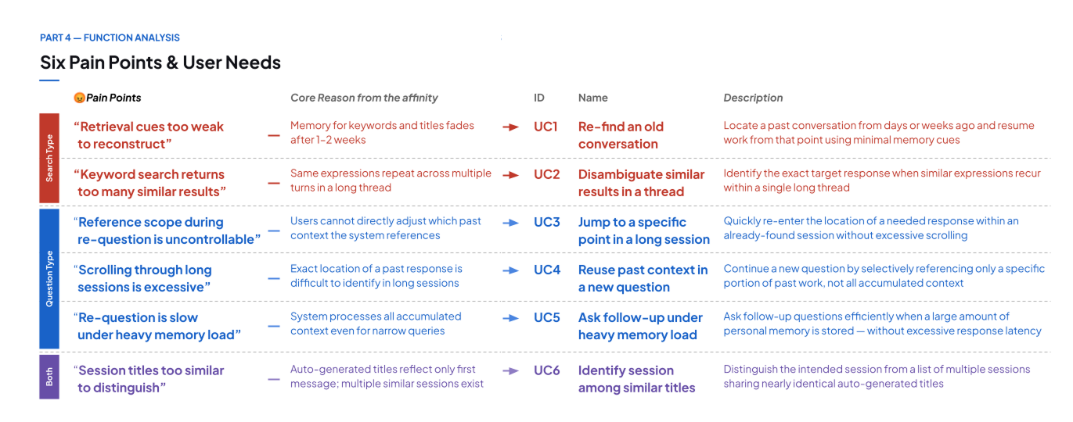
A-2. Requirements and Function Mapping from Use Cases
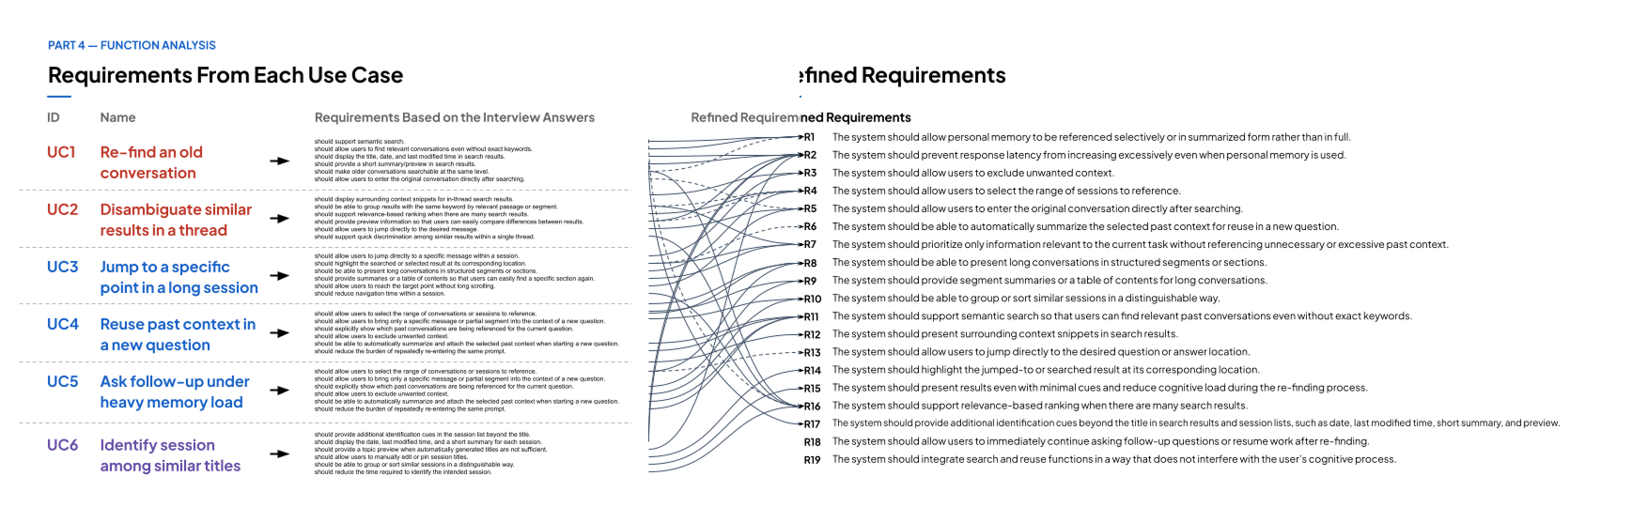

Appendix B. Morphological Chart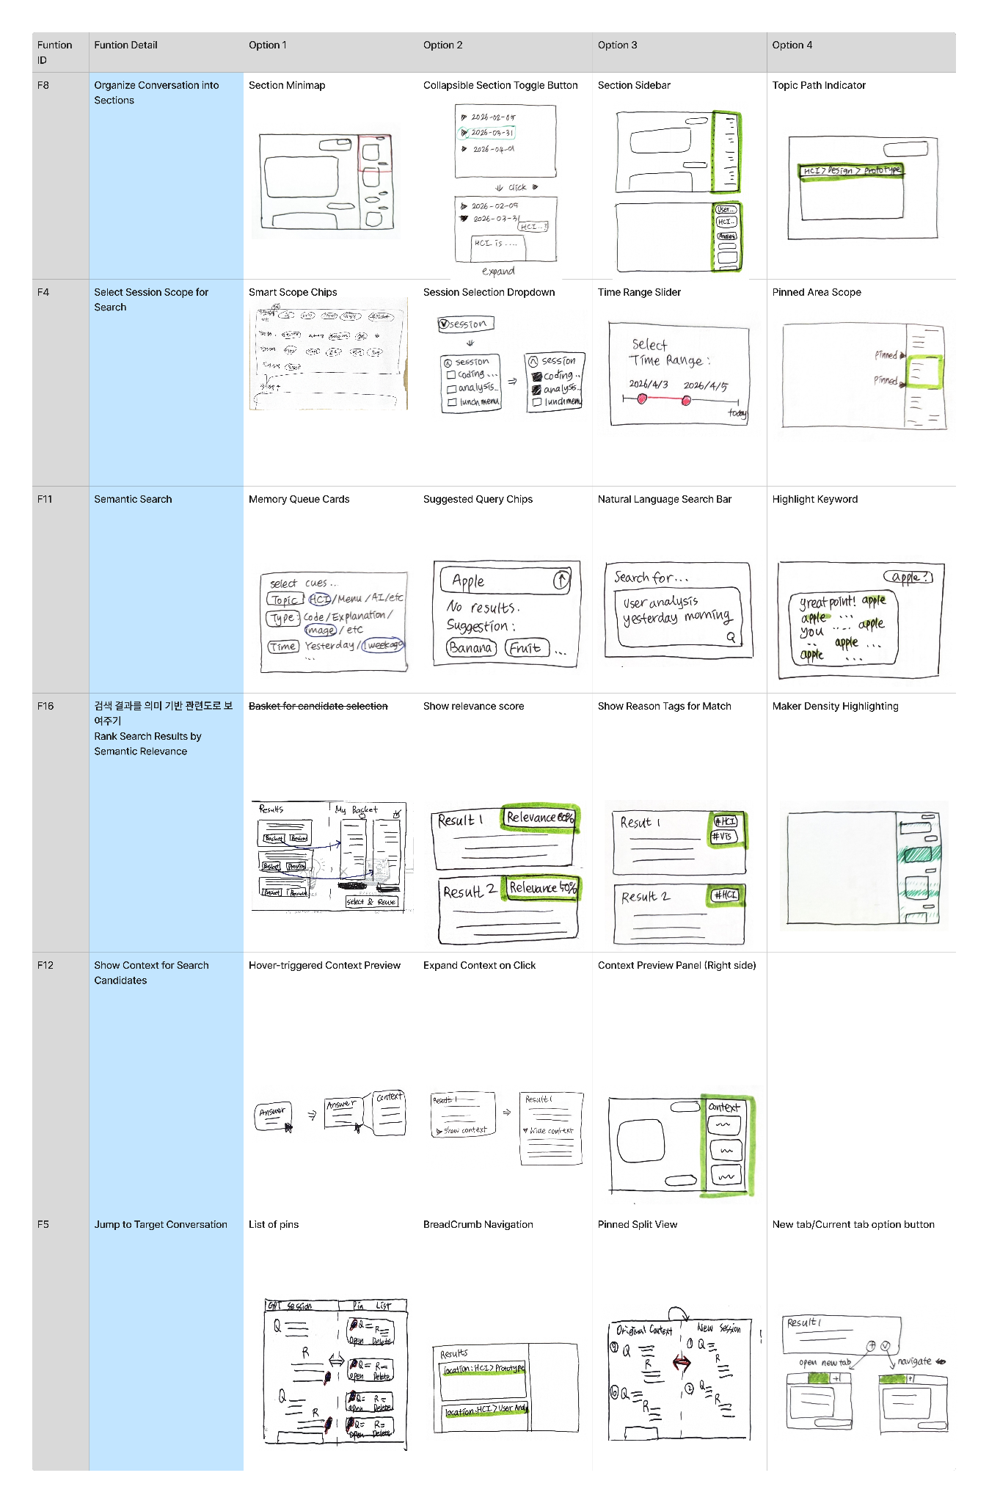
Appendix C. Figures for Design Alternatives
C-1. Alternative 1
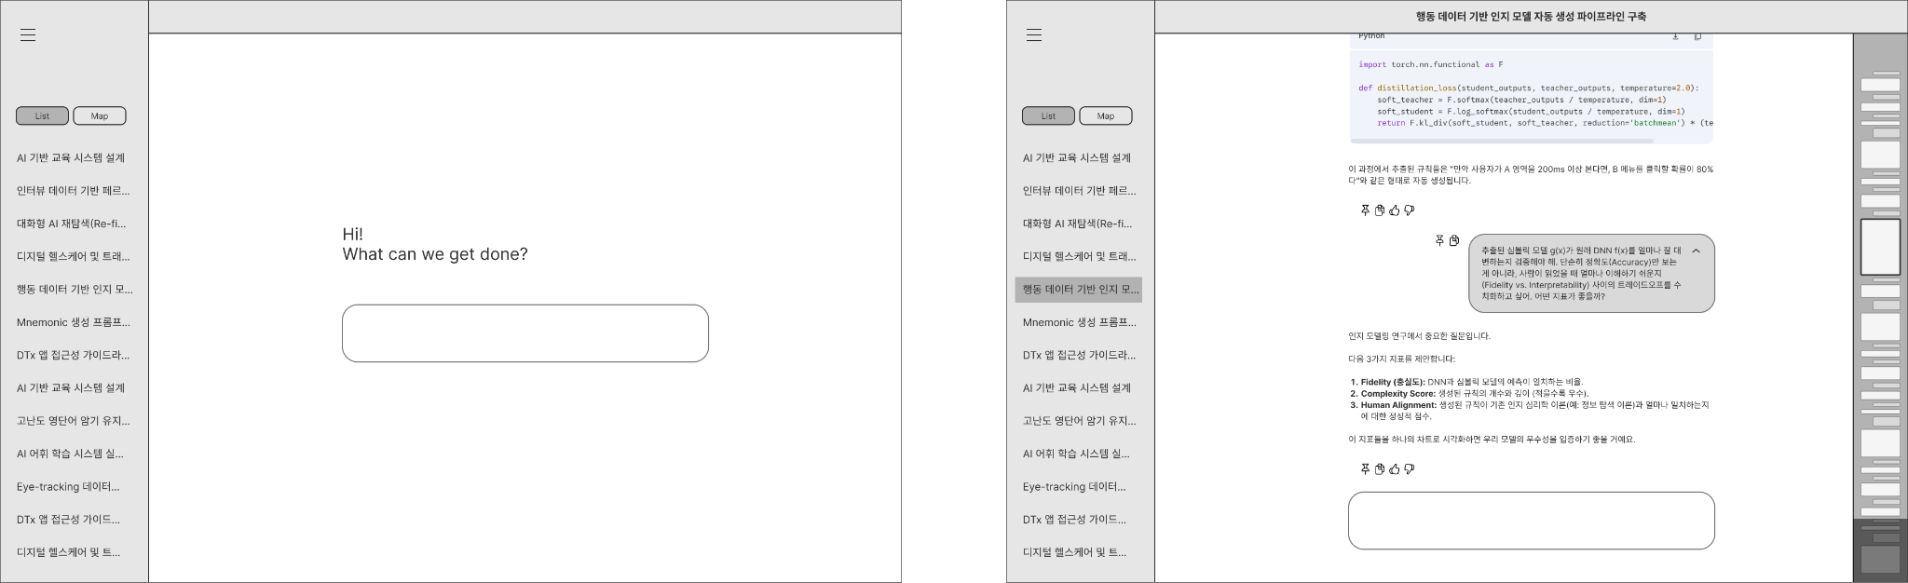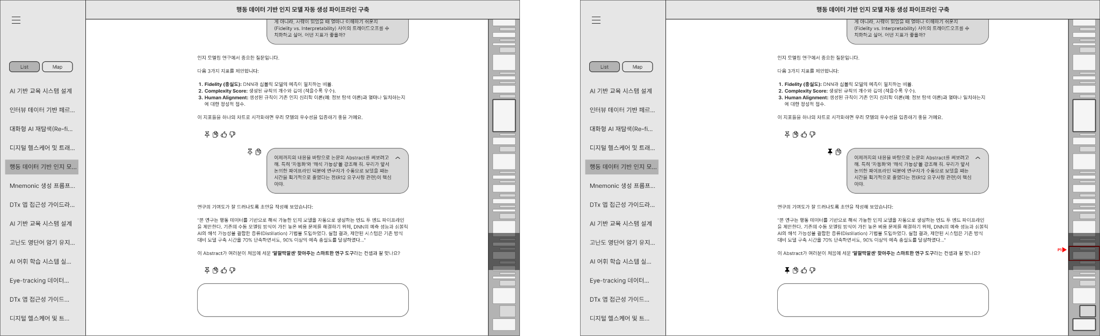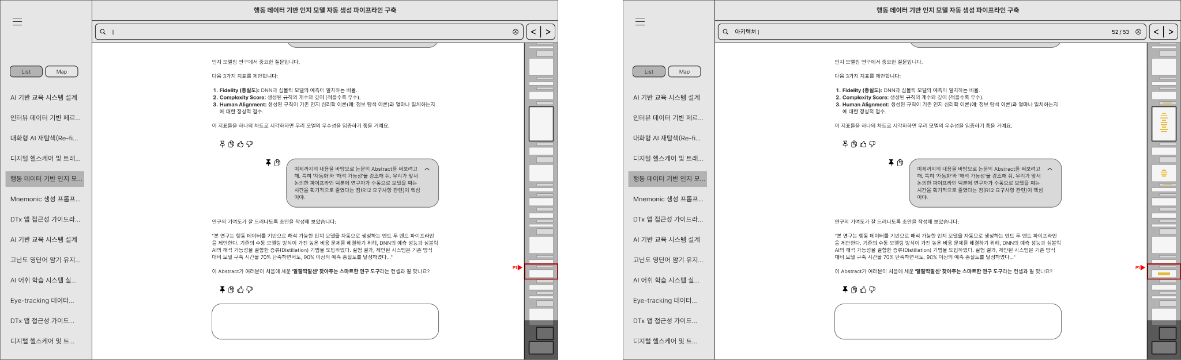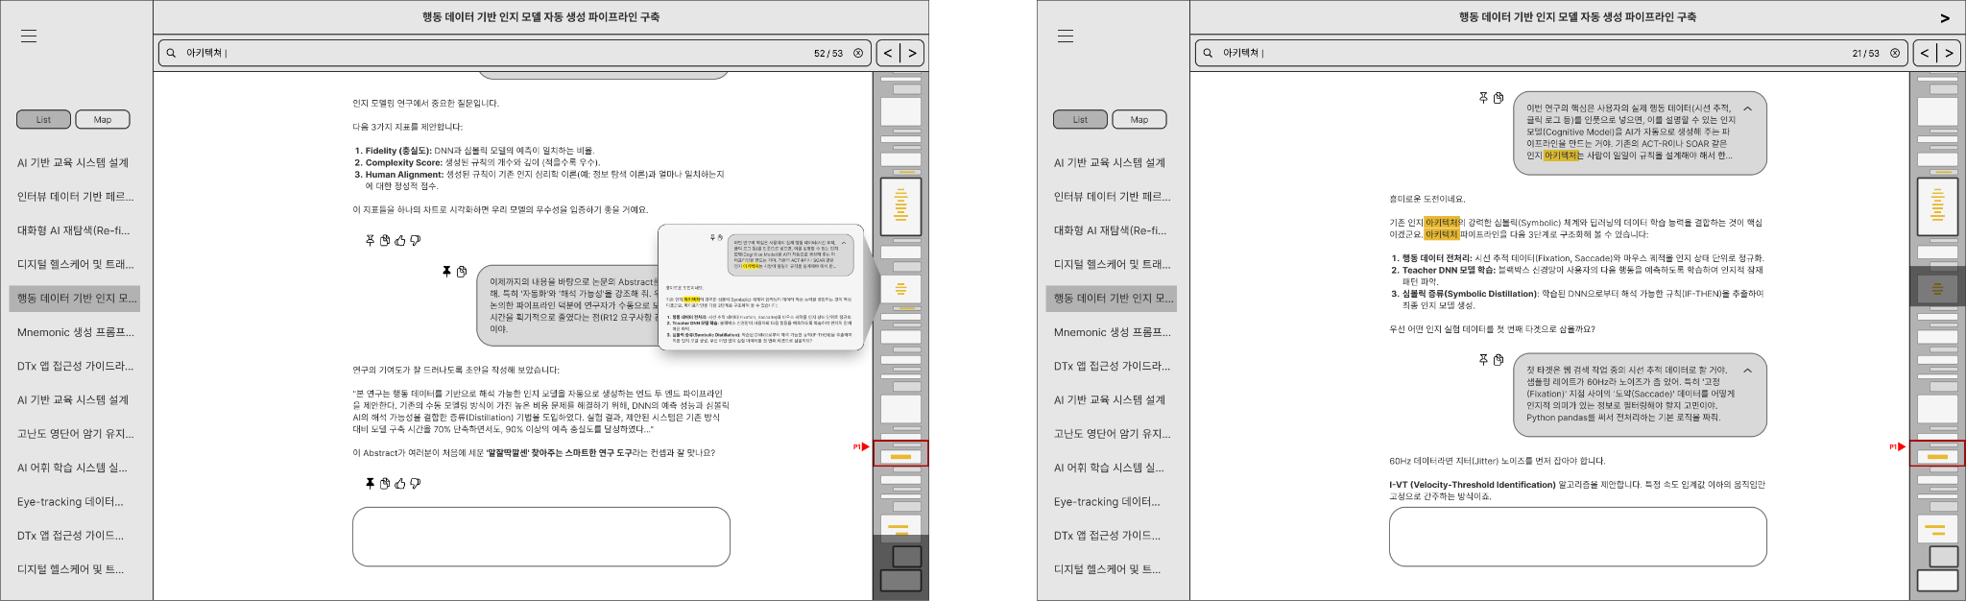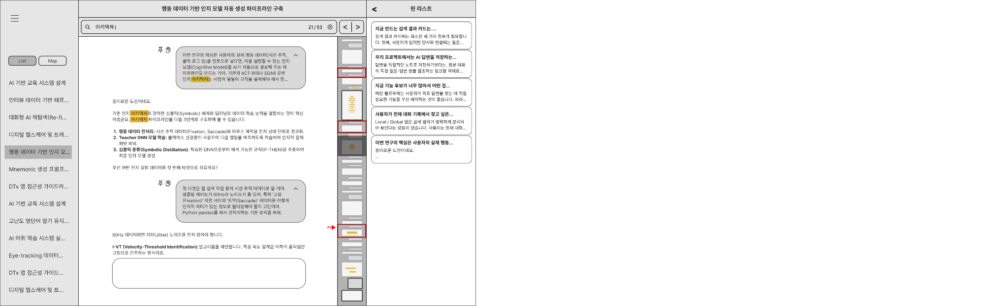

C-2. Alternative 2
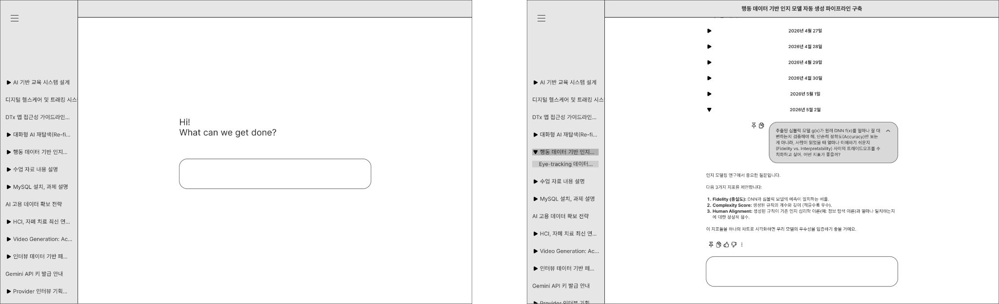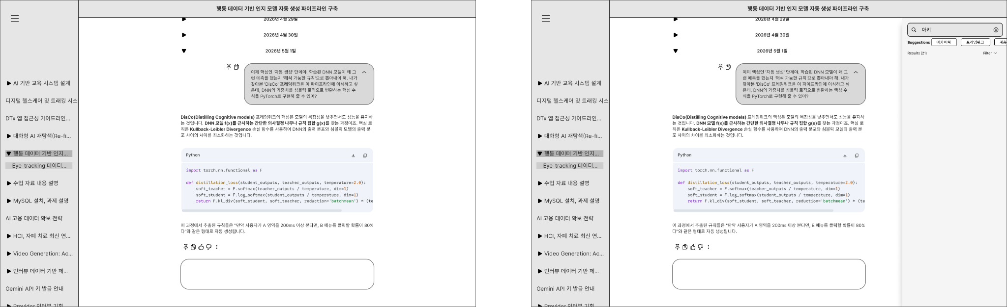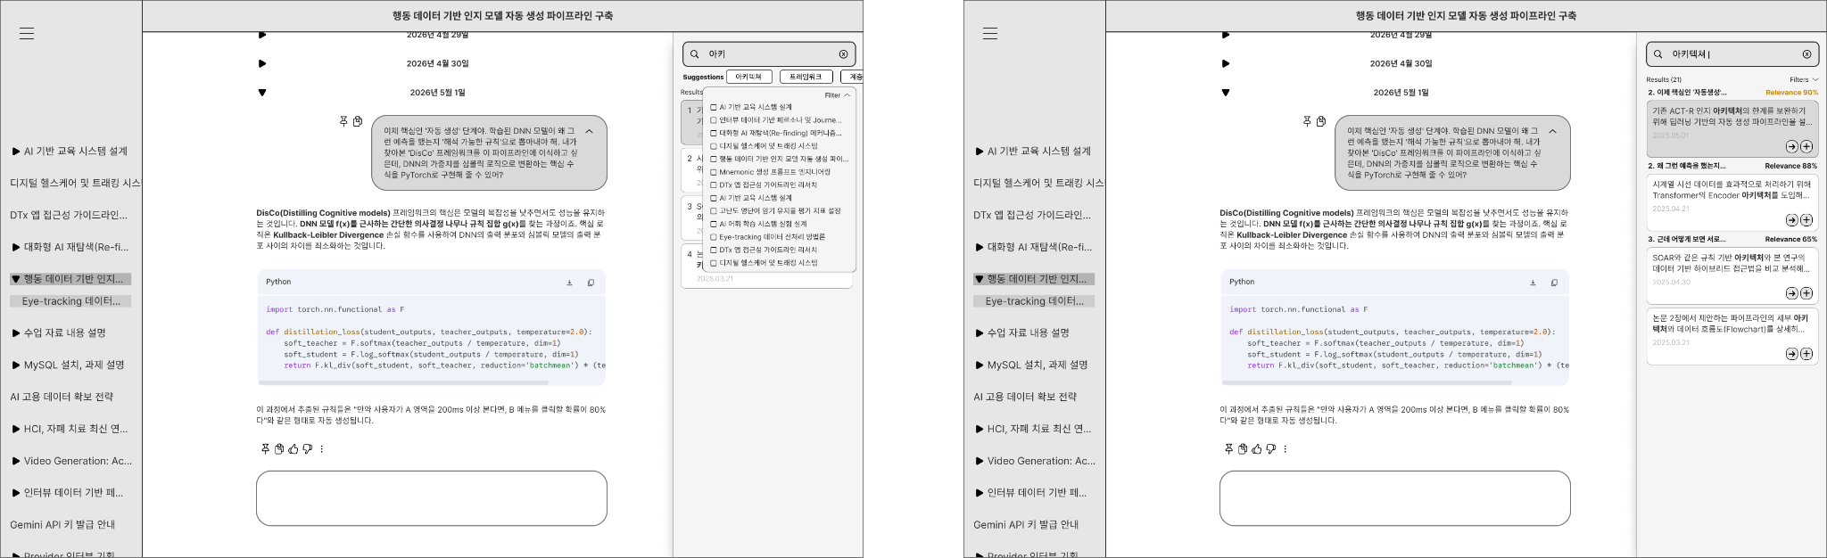

C-3. Alternative 3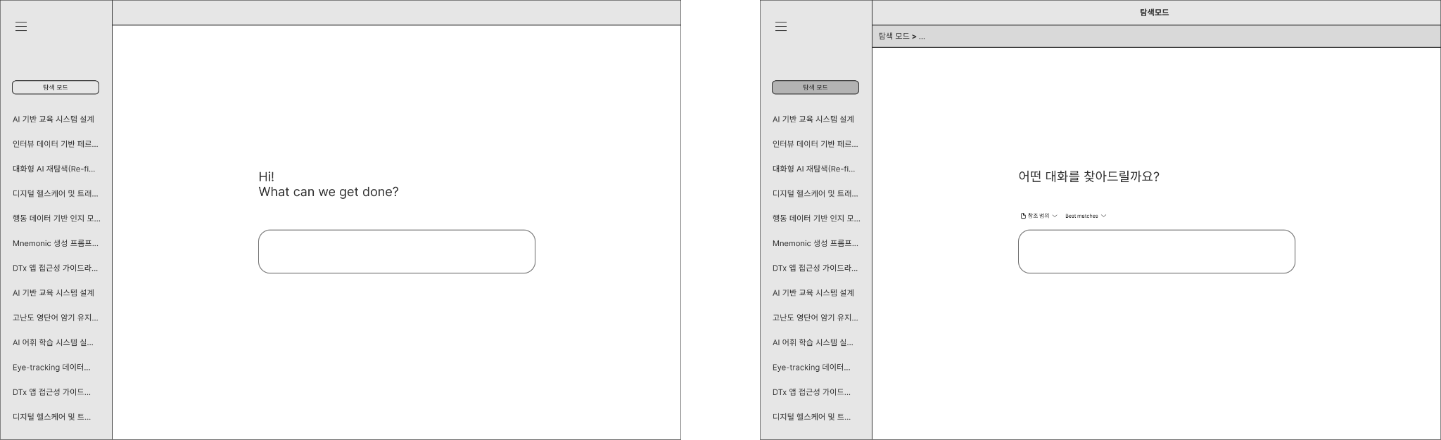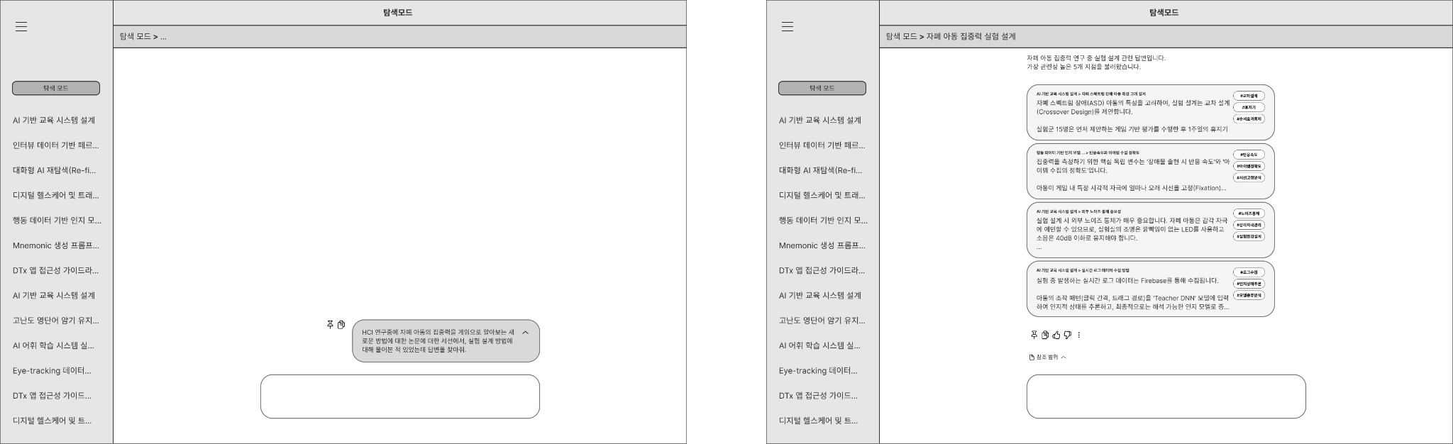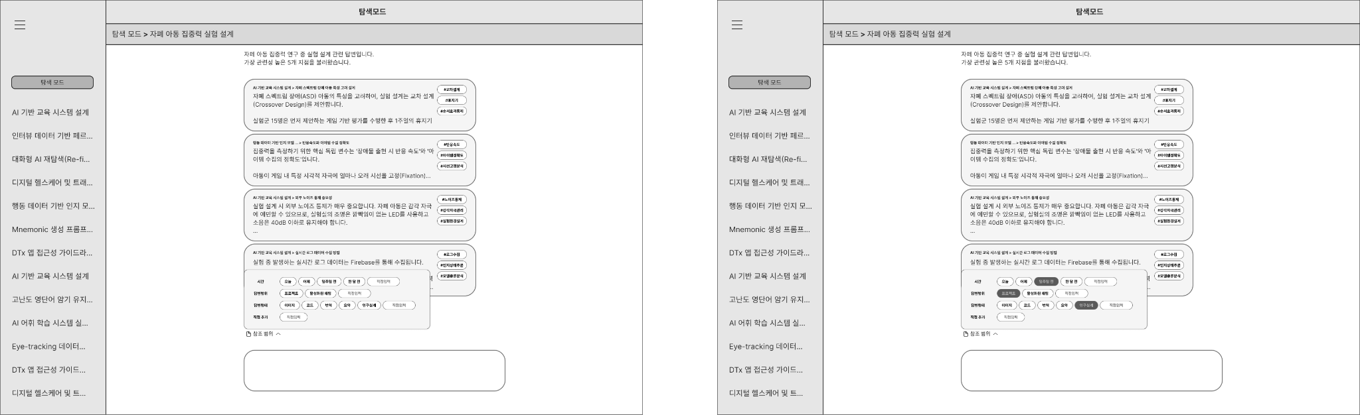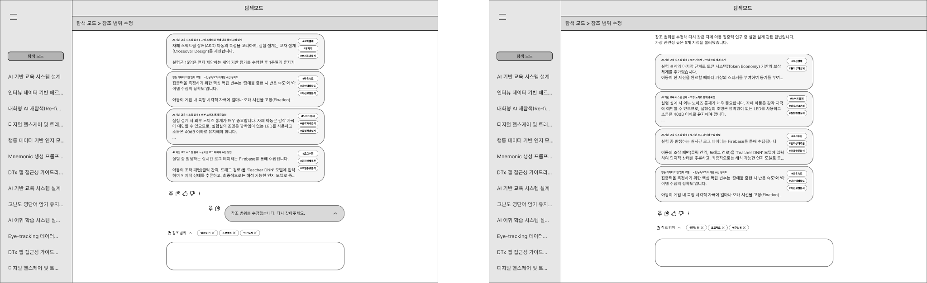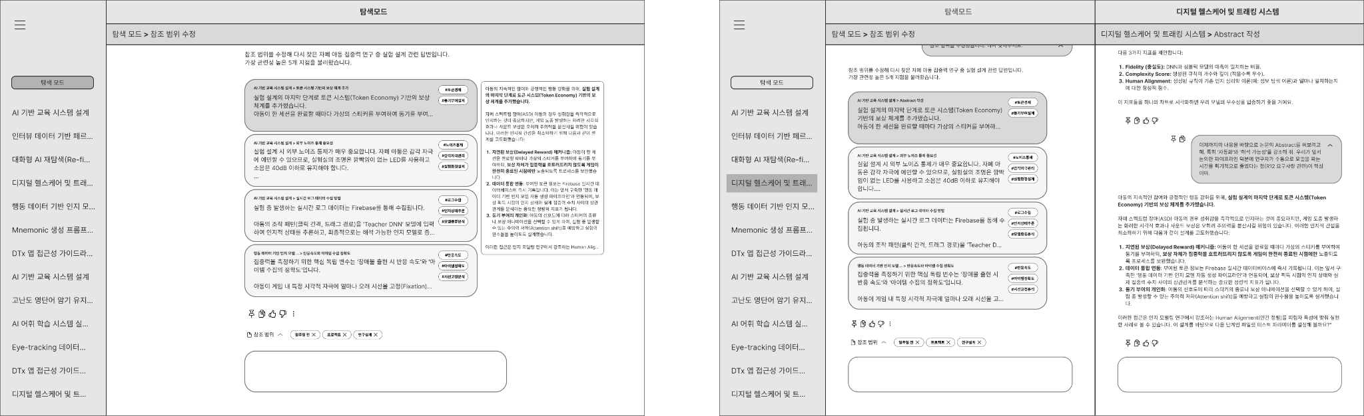

Appendix D. Alternative Evaluation Survey
This survey evaluates the anticipated usefulness, cognitive load, flow maintenance, and privacy concerns of a refinding feature designed to help users locate and reuse content from past conversations in conversational AI systems (e.g., ChatGPT, Gemini, Claude). Since this feature is presented as a concept or prototype rather than a fully implemented service, please respond based on how you would expect to feel or behave if you were to use the feature, based on the provided description and screen examples.
All items are rated on a 7-point scale: 1 = "Strongly disagree / Very unlikely," 4 = "Neutral / Neither agree nor disagree," 7 = "Strongly agree / Very likely."
There are no right or wrong answers. Please respond honestly based on your personal expectations and concerns regarding the feature.
This study is conducted as part of a course assignment for the Graduate School of Culture Technology's HCI course (2026) and has been approved by the course instructor.

Section 1. Task Effectiveness
1. I think I would be able to find the target answer I was looking for using this feature.
2. I think I would feel that the system understands the context of what I am trying to find.
3. I think this feature would help me reliably locate past conversations.
4. I expect to be able to find what I want through this feature even without remembering the exact keywords or context.
5. I think I would be able to easily distinguish between the different search results provided by this feature.
6. I think I would be able to find what I want more quickly using this feature than with existing methods.
7. I think I would not need to keep changing or struggling to recall search terms in order to find what I want.
8. I think I would be able to conveniently navigate to the location of the answer found through this feature.

Section 2. Context Resumption
9. I think this feature would provide sufficient context to resume a task I had stopped.
9-1. (Open-ended) How many follow-up prompts (re-queries) do you think would be needed to resume the task? (e.g., 1 time, 4 times)
10. I think I would be able to immediately continue with follow-up questions or tasks based on the content I found.
11. I think I would be able to find past content while maintaining the current conversation flow.
11-1. (Open-ended) How long do you think it would take to set up the desired task context using this feature? (e.g., 3 minutes, 20 minutes)
12. I think this feature would not interrupt the conversation currently in progress.
13. I think I would be able to find what I want without remembering exact keywords, dates, or session titles.

Section 3. Interaction Cost
14. I think I would feel confused by too much information displayed on the screen when using this feature.
15. I think the process of selecting one result from the search results would take a long time.
15-1. (Open-ended) How long do you think it would take to select one item from the search result list? (e.g., 10 seconds, 30 seconds, 1 minute)
16. I think using this feature would not require many clicks or screen transitions to find the target content.
16-1. (Open-ended) How many clicks do you think you would make on average? (e.g., 1, 3)
16-2. (Open-ended) How many screen transitions do you think would be needed?
17. I think I would not need to modify my search query multiple times to find what I want.
17-1. (Open-ended) How many times do you think you would need to revise your search query on average?
18. I think I might feel frustrated or fatigued while using this feature.
19. I think I might want to give up searching midway and try a different approach.
19-1. (Open-ended) After how many failed attempts would you give up and try another method?
19-2. (Open-ended) After how many minutes of searching would you give up and try another method?
20. I think I would want to use this feature again.

Section 4. Privacy & Control
21. I think this feature would only use conversation history within the range I have permitted.
22. I think I would be able to understand which range of conversations this feature is referencing.

Section 5. System Performance
23. I think this feature would provide search results or candidate recommendations quickly.
24. I think previews, dashboards, minimaps, and tree views in this feature would load quickly.
24-1. (Open-ended) How many seconds do you think the loading would take?
24-2. (Open-ended) How many seconds of loading time would feel inconvenient?
25. I think I might feel that past conversations are exposed more than necessary when using this feature.
26. I think I would be able to directly control the search scope or reference range in this feature.
Appendix E. Post-Interview Results
Participant | Prototype | Sentiment | Score | Comment
P1 | Alt 1 | Neutral | 0 | Direct navigation without scrolling is nice. But if you already remember what was said, Cmd+F might be faster — do we really need a summary panel cluttering the side?
P2 | Alt 1 | No comment | 0 | (No comment)
P3 | Alt 1 | Positive | 2 | It's a step up from Cmd+F, which is a plus.
P4 | Alt 1 | Positive | 1 | The search itself isn't groundbreaking, but the pinpoint feature was nice and seems helpful for locating things more easily.
P5 | Alt 1 | Negative | -2 | It feels like just a marginally more convenient Cmd+F. I'd still need to open each result to see how keywords are connected. Reducing 53 Cmd+F hits to 3–4 is useful, but whether that actually matters enough warrants more thought.
P6 | Alt 1 | Positive | 3 | Liked it the most; felt it was the most useful.
P7 | Alt 1 | No comment | 0 | (No comment)
P8 | Alt 1 | No comment | 0 | (No comment)
P1 | Alt 2 | Neutral | 0 | The branch feature seems genuinely useful. Not sure how this connects to refinding though. Date-based chunking feels off — context-based chunks would be better. If I'm already picking a date range, why not just use Cmd+F?
P2 | Alt 2 | Positive | 1 | If I roughly know where something is, I can probably find it without this. That said, showing results as cards isn't bad.
P3 | Alt 2 | Negative | -3 | Tabs within tabs feels like a disaster — way too complex.
P4 | Alt 2 | Positive | 1 | Similar to the pinpoint feature, but the ability to create a new branch is useful. Still, pinpoint felt more impactful overall.
P5 | Alt 2 | Positive | 2 | Scrolling burden is reduced. Having results appear in a consolidated panel feels more manageable than the local minimap.
P6 | Alt 2 | Negative | -2 | I already knew about branch, but never use it, so this didn't feel meaningful. Just seems like more memory usage.
P7 | Alt 2 | Neutral | 0 | After pinning and navigating by date, I couldn't figure out how to return to the pin. A back-navigation feature would be helpful.
P8 | Alt 2 | No comment | 0 | (No comment)
P1 | Alt 3 | Neutral | 0 | Resource cost is a concern. Returning the original answer verbatim would be ideal, but feasibility under resource constraints is unclear. Also, questions that didn't make sense earlier became clear by this prototype — potential order bias?
P2 | Alt 3 | Positive | 1 | I had thought something like this would be useful, and seeing it in action, it seems decent.
P3 | Alt 3 | Negative | -2 | Not a fan of setting the scope via checklist. Adjusting it by re-querying feels more natural and intuitive.
P4 | Alt 3 | Neutral | 0 | Being able to define the reference scope myself is good — avoids token waste. But if scope selection is title-based, inaccurate titles could slow things down.
P5 | Alt 3 | Neutral | 0 | Natural language input is intriguing, but it'd need a capable LLM to be trustworthy. Could get slow if it ends up like Deep Research. Scope control is a plus.
P6 | Alt 3 | Negative | -1 | Feels like AI inside AI.
P7 | Alt 3 | No comment | 0 | (No comment)
P8 | Alt 3 | No comment | 0 | (No comment)

Appendix F. Expert Interview Protocol
Category | Question | Response Format
Technical Feasibility | Do you think Refinding Mode can be implemented using only the standard conversation storage structure of current commercial Conversational AI systems? | 5-point Likert scale
Data Architecture | Do you think implementing Refinding Mode requires additional indexing, embedding, or metadata storage structures beyond the existing conversation database? | 5-point Likert scale
Technical Feasibility | When users enter ambiguous cues such as “that answer you explained before,” do you think current LLM-based retrieval technologies can reliably find the target answer? | 5-point Likert scale
Retrieval Pipeline | When a user submits a refinding query, do you think semantic search alone is sufficient, or is additional LLM-based reranking or reasoning required? | 5-point Likert scale & Open-ended response
Data Architecture | What information do you think should be pre-generated at the time of conversation to implement Refinding Mode reliably? | Multiple choice
Latency & Cost | Compared to conventional keyword search, how much higher do you expect the real-time computational cost of Refinding Mode to be for each user request? | 5-point Likert scale
Latency & Cost | Do you think the average response latency of Refinding Mode can be maintained at a user-acceptable level? | 5-point Likert scale
Latency & Cost | What do you think is an appropriate maximum loading time that users would tolerate for Refinding Mode? | Multiple choice
Latency & Cost | What do you think would be the biggest bottleneck when applying Refinding Mode to a commercial service? | Multiple choice
Privacy & Safety | Do you think long-term storage and processing of users’ past conversations for Refinding Mode could raise privacy concerns? | 5-point Likert scale
Privacy & Safety | Do you think Refinding Mode carries a risk of recommending incorrect past answers or generating hallucinated references? | 5-point Likert scale
Retrieval Pipeline | In Refinding Mode, do you think it is necessary for the LLM to summarize differences among candidate results rather than simply returning search results? | 5-point Likert scale
Open-ended Expert Judgment | If Refinding Mode were to be deployed in a real service, what technical risk should be validated first? | Open-ended response

Appendix G. Prototype Figures
